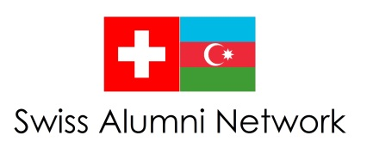

Meeting of the Swiss Ambassador with Former Azerbaijani Students (Alumni) in Switzerland

This year (May/June), the Swiss Embassy in Baku will organize an Alumni reception at the Ambassador’s residence for all those Azerbaijani citizens who performed all or part of their education in Switzerland.

Please help us keep our alumni list up to date. If you are interested in participating in the reception, please fill out the attached form. This will enable us to send you an invitation.

Inscription Form

Name / Surname
Address
Telephone
Mobile Telephone
Studies in Switzerland

- from / to

- University / School

- Faculty

- Other

Current Profession
Place / Date

Thank you for sending this form to:

bku.vertretung@eda.admin.ch

